**iOS Lean Controllers: 1 Setup, Persistent Data, and Implementation**

16-Nov-2021

[Course Link - LinkedIn](https://linkedin.com/learning/ios-lean-controllers-1-setup-persistent-data-and-implementation)

1. **Getting Started**

* **Massive view controllers**
* 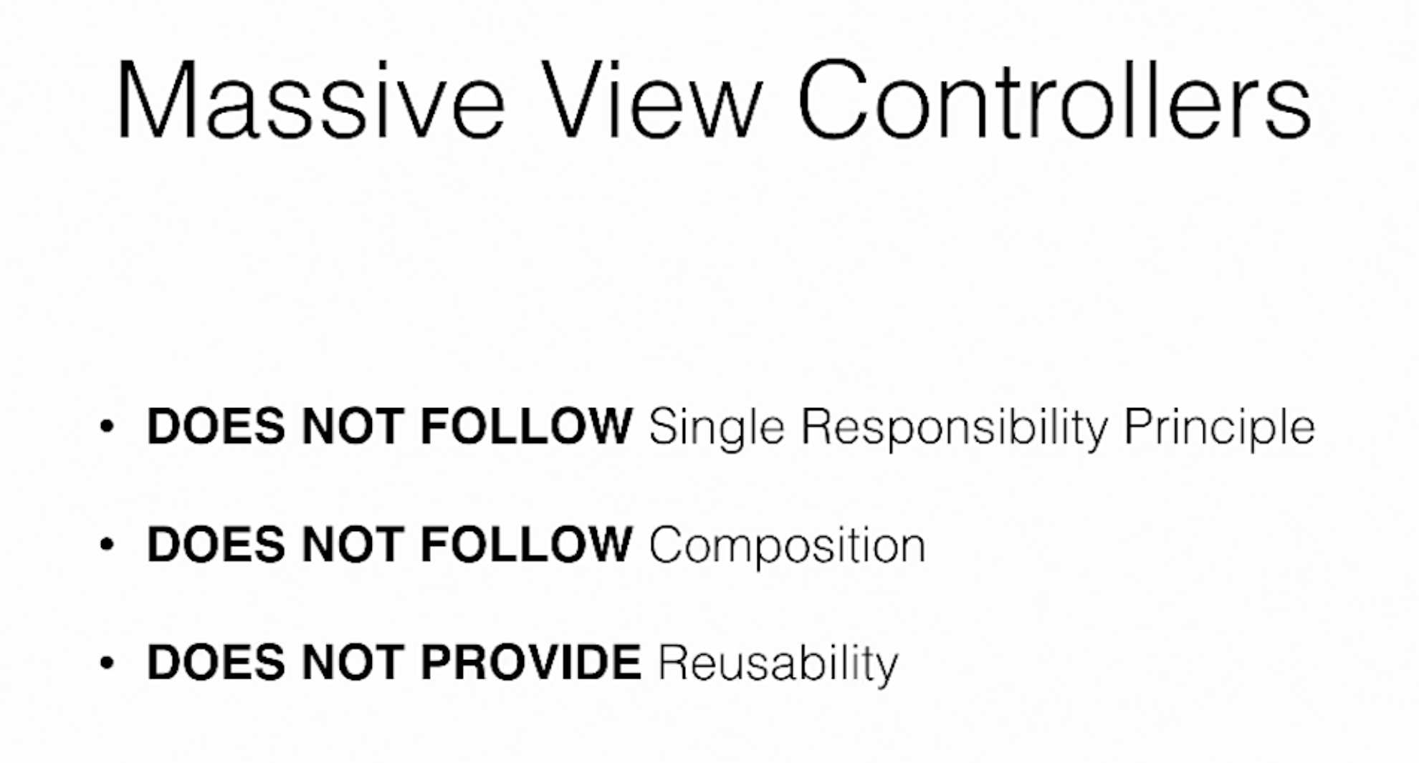
* 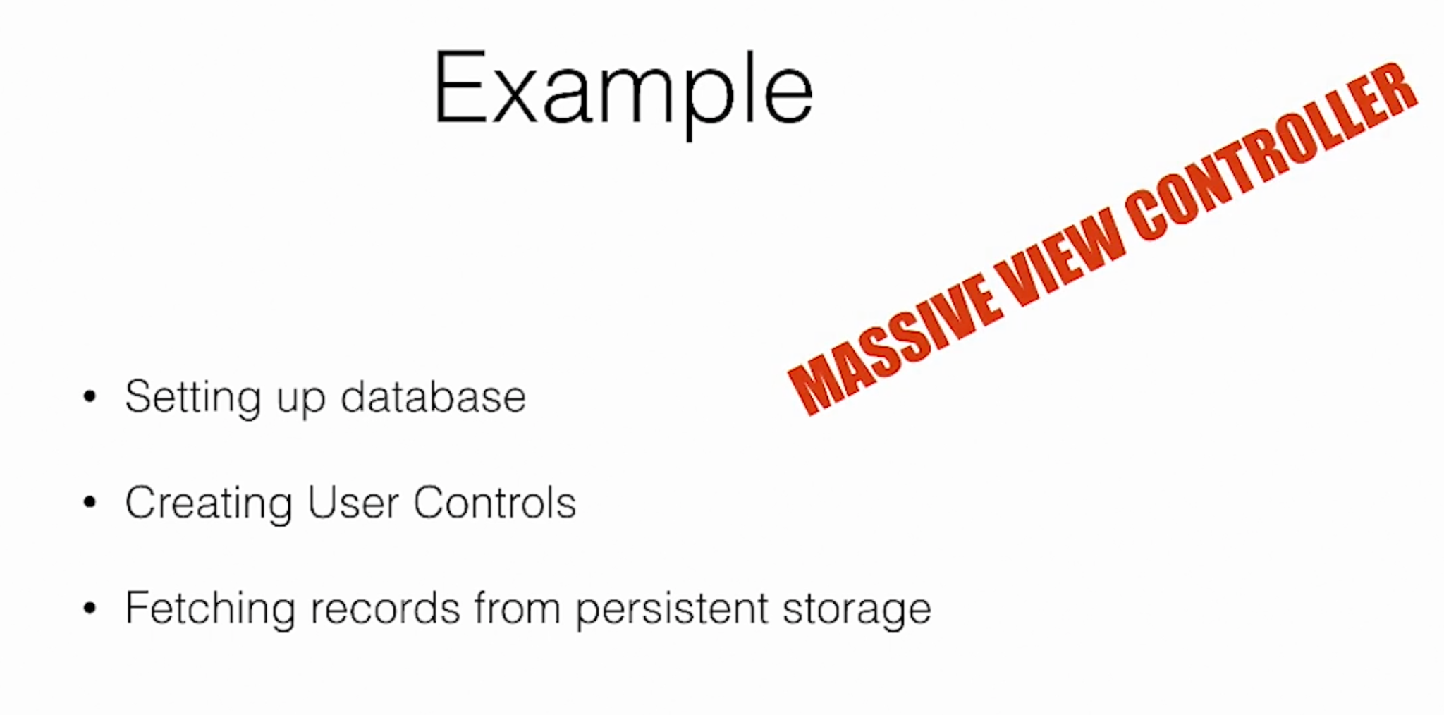
* **Lean controller**
* 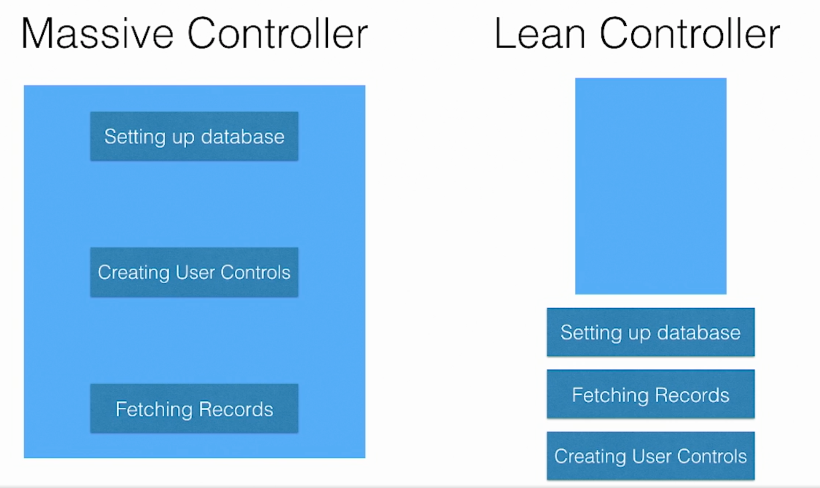

1. **Setting Up the Grocery Application**

## **Designing wireframes using Keynote**

* 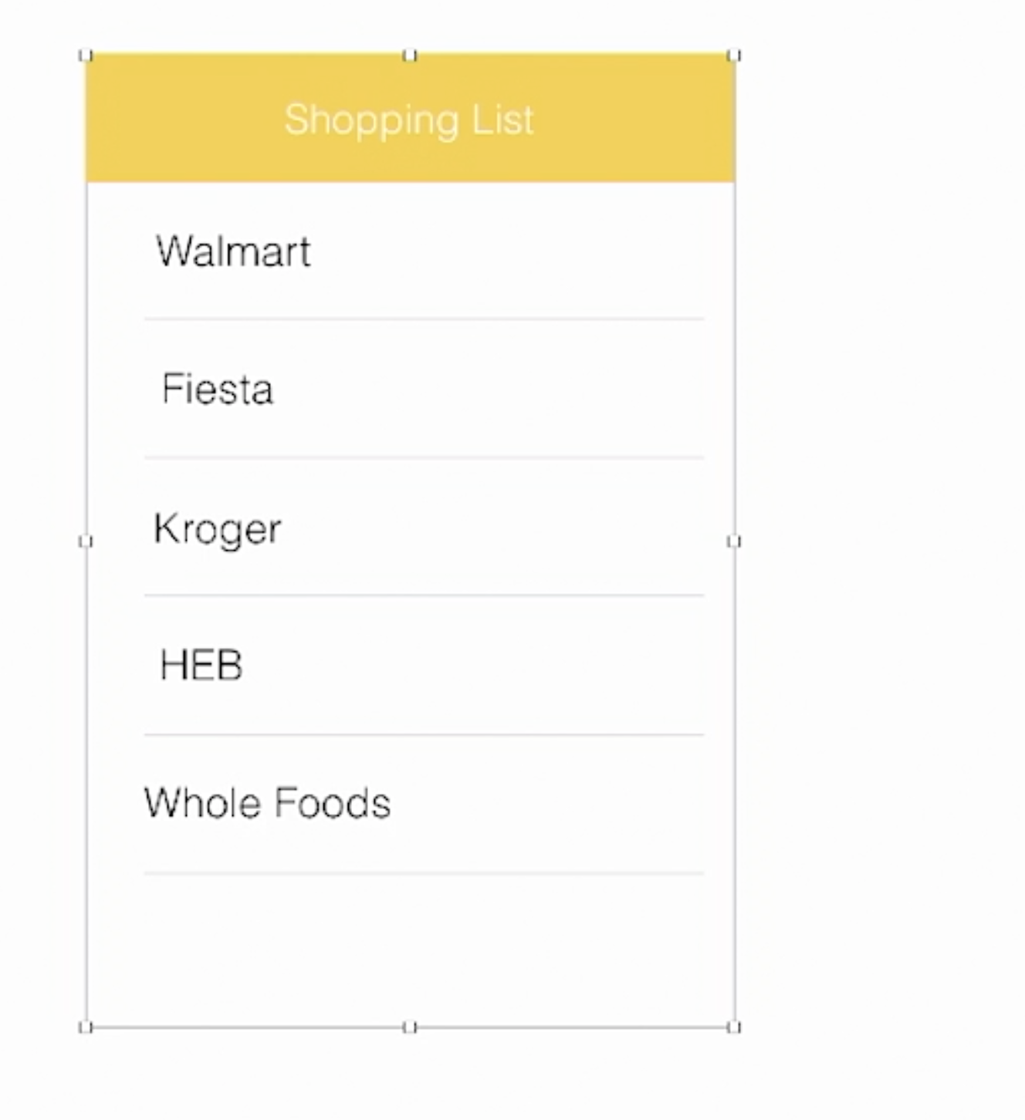

## **Implementing the user interface in storyboards**

* + Added a tableViewController in main.storyboard and embedded in a Navigation controller
  + Created ShoppingListsTableViewController

## **Integrating with Core Data**

* + Set up Core Data with ShoppingListsTableViewController
  + Created MyGroceryDataModel.xcdatamodelId

## **Creating a custom view to add a new shopping list**

* + Added header section to add items to the list
  + Used tableView delegates methods viewForHeaderInSection and heightForHeaderinSection

1. **Persisting data using Core Data**

* **Saving New Record**
  + textFieldShouldReturn delegate for TextView
  + Save entered values to core data
* **Fetching and displaying records in UITableView**
  + Set fetchResultController and confirm with NSFetchResultControllerDelegate
  + Set table view rows and cellForRow
* **Deleting records**
  + Add tableView delegate method commit editingStyle and add delete action from core data
  + Handle fetchResultController didChange delegate for inserting and deleting

1. **Implementing Data managers and Providers**

* **Implementing Core Data manager**
  + Add CoreDataManager class and move initializeCoreDataStack() and managedObjectContext into it
  + Initialize Core Data and pass managedObjectContext from AppDelegate to ShoppingListsVC
  + Handle ShoppingListsVC
* **Implementing shopping list data providers**
  + Create ShoppingListDataProvider class and move fetchResultController logic from ShoppingListsVC

1. **Implementing and Configuring Data sources**

* **Implementing shopping list data sources**
  + Create ShoppingListDataSource class and move tableView data source methods from ShoppingListsVC
  + Handle ShoppingListDataSource with ShoppingListDataProvider
* **Communicating between the data provider and data source**
  + Pass tableView into ShoppingListDataSource class
  + Create ShoppingListDataProviderDelegate protocol for communication
* **Deleting shopping lists using the data source and provider**
  + Add delete method in ShoppingListDataProviderDelegate protocol
  + Handle delete object in ShoppingListDataSource and ShoppingListDataProvider classes

**iOS Lean Controllers: 2 Controls, Views, Extensions, and Networking**

17-Nov-2021

[Course Link - LinkedIn](https://www.linkedin.com/learning/ios-lean-controllers-2-controls-views-extensions-and-networking)

1. **Creating Custom Controls**

* **Creating a custom add new item control**
  + Create AddNewItemView and move header code from ShoppingListsVC
* **Adding the custom initializer to configure placeholder text**
  + New Initializer for AddNewItemView with controller and placeholder as parameters
* **Passing data from AddNewItemView using Delegates**
  + Create AddNewItemViewDelegate and handle save new entered shopping list item
* **Passing data from AddNewItemView using closures**
  + Pass an escaping closure with initializer and handle save new entered shopping list item

1. **Generic Data Providers and Data Sources**

* **Creating a generic data provider**
  + Create FetchedResultsDataProvider and FetchedResultsDataProviderDelegate
* **Implementing a generic TableView data source: Part 1**
  + Create TableViewDataSource class
* **Implementing a generic TableView data source: Part 2**
  + Set up TableViewDataSource with ShoppingListsVC with closure
* **Saving records using generic providers and data sources**
  + Handle insert and delete actions

*****Finished MyGrocey App*****

Additional Topics

1. **Building Better View Controller Segues**

## **Default segues**

* + Using prepare(for segue: UIStoryboardSegue, sender: Any?) delegate method
* **Modern segues using extensions**
  + Set a protocol segueHandler for handling segues with enum

1. **Secure TabBar items using protocol extensions**

* Create a LoginHandler protocol
* Create BaseTabBarController and confirm with UITabBarControllerDelegate and handle with LoginHandler
* Confirm Tabs controllers with LoginHandler to secure for login cases

1. **Building UIControl Extensions**

* Move button creation into UIButton extensions
* Add UIView extension to add Layout constraints